White Sings

Hwa Seo

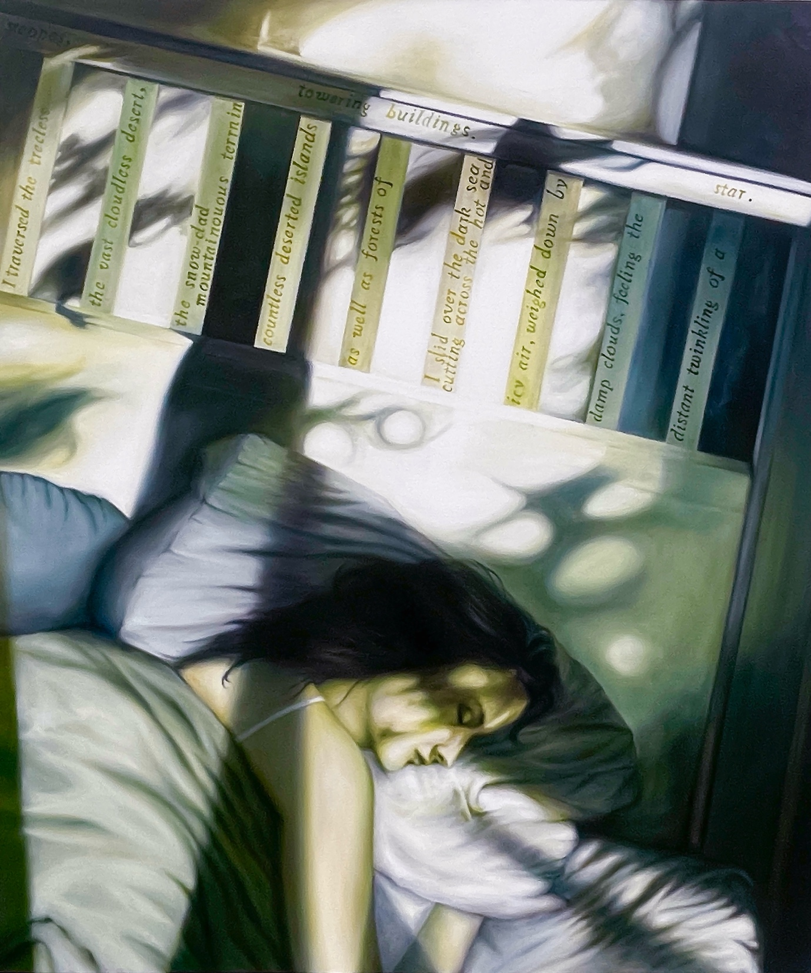
White in Green—Repose, 130 x 150 cm, oil on canvas, 2024

White in Green—Repose

I traversed the treeless steppes, the vast cloudless desert, the snow-clad mountainous terrain, countless deserted islands, as well as forests of towering buildings.

I slid over the dark sea, cutting across the hot and icy air, weighed down by damp clouds, feeling the distant twinkling of a star.

For three days and nights, I ran without a break. Now, here I am, beside you, as you called me.

I will erase your stained memories that cling to you. With my touch of ivory-white light, they will disappear.

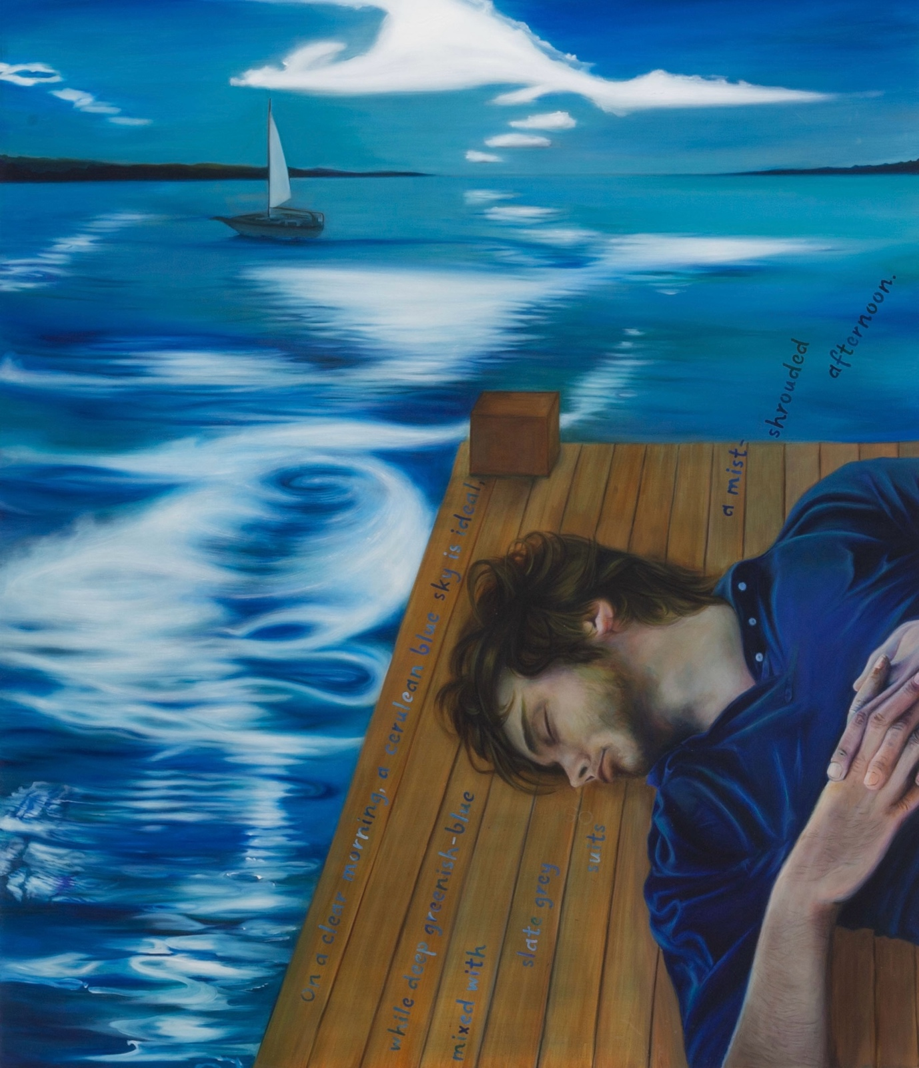
White on Blue—Blue, 130 x 150 cm, oil on canvas, 2025

White on Blue—Blue

On a clear morning, a cerulean blue sky is ideal, while deep greenish-blue mixed with slate grey suits a mist-shrouded afternoon. In bright summer, pale ultramarine with a puff of emerald green feels right, while Prussian blue tinged with deep grey suits a wintry night.

I showcase my presence in the blue skies, shifting my white glow as the sun casts ever-changing light each moment. You can see me, but never stroke my skin, neither in the sky nor on a vast sea-like lake, where my body is reflected upon the silver ripples.

On a vapour-laden afternoon, part of you, while sleeping, feels a distance beyond reach. The immaterial whiteness of my burst of air drifts around you on the water to soothe your indefinite emptiness with faded scars.
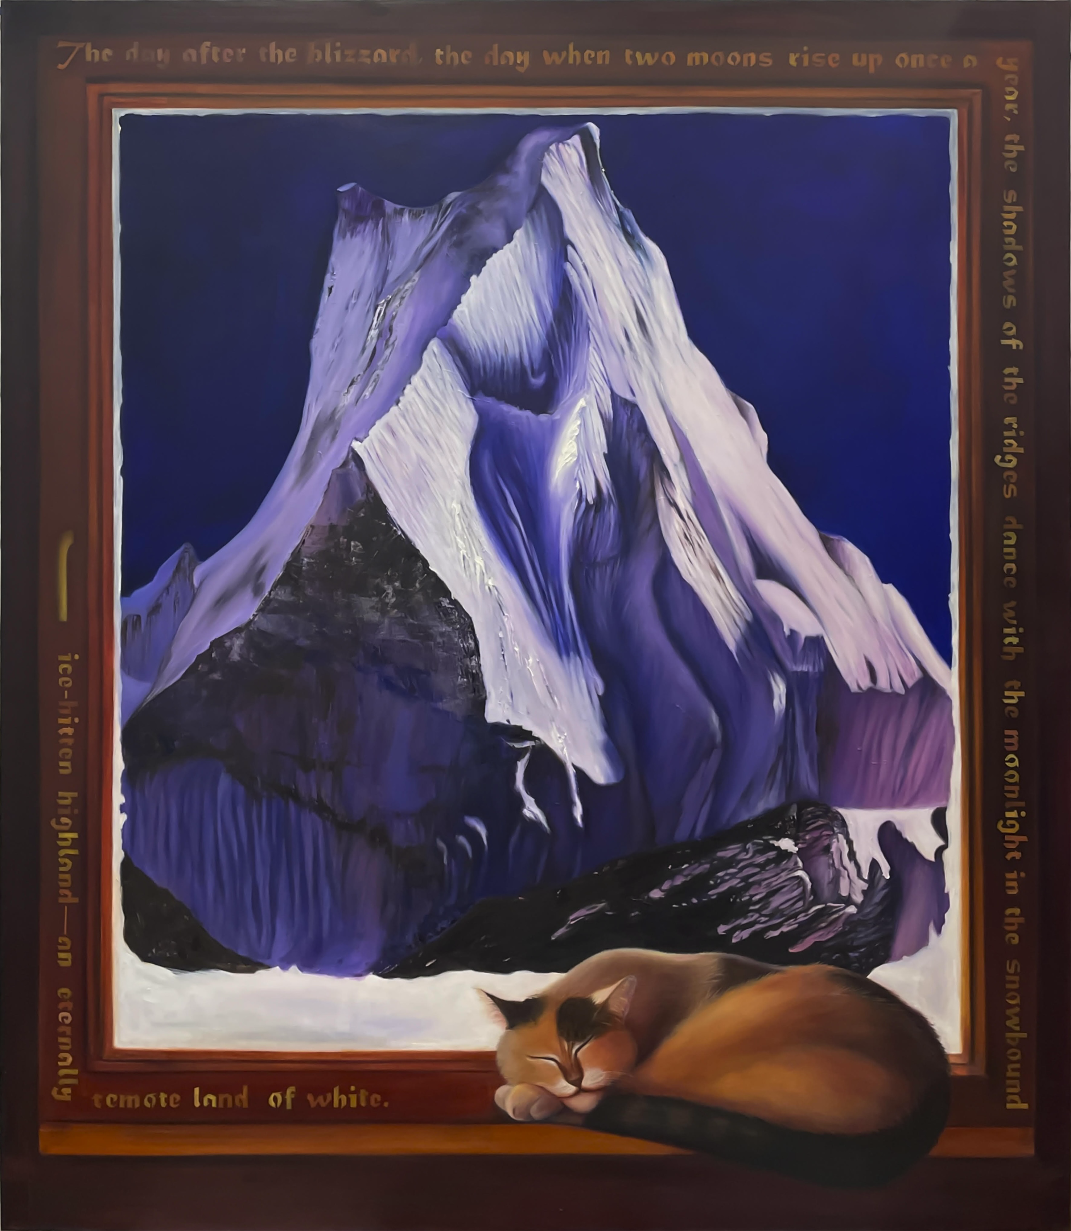
White on Violet—When Two Moons Rise Up, 130 x 150 cm, oil on canvas, 2025

White on Violet—When Two Moons Rise Up

The day after the blizzard, the day when two moons rise up once a year, the shadows of the ridges dance with the moonlight in the snowbound, ice-bitten highland—an eternally remote land of white. I warmly welcome you all to this year’s ice festival.

In the quiet of the dead of night, you are mesmerised, you may want to search for my kingdom of snow through the Wikipedia roadmap, but your efforts will be futile. I’m visible only to those who are becoming sensitive to strange noises with vigilance and desensitising their faces parching over and over after the streams of resentment and betrayal, violence and sorrow.

My metal-freeze white is cold yet oddly comforting, so you invite me into your dreams.

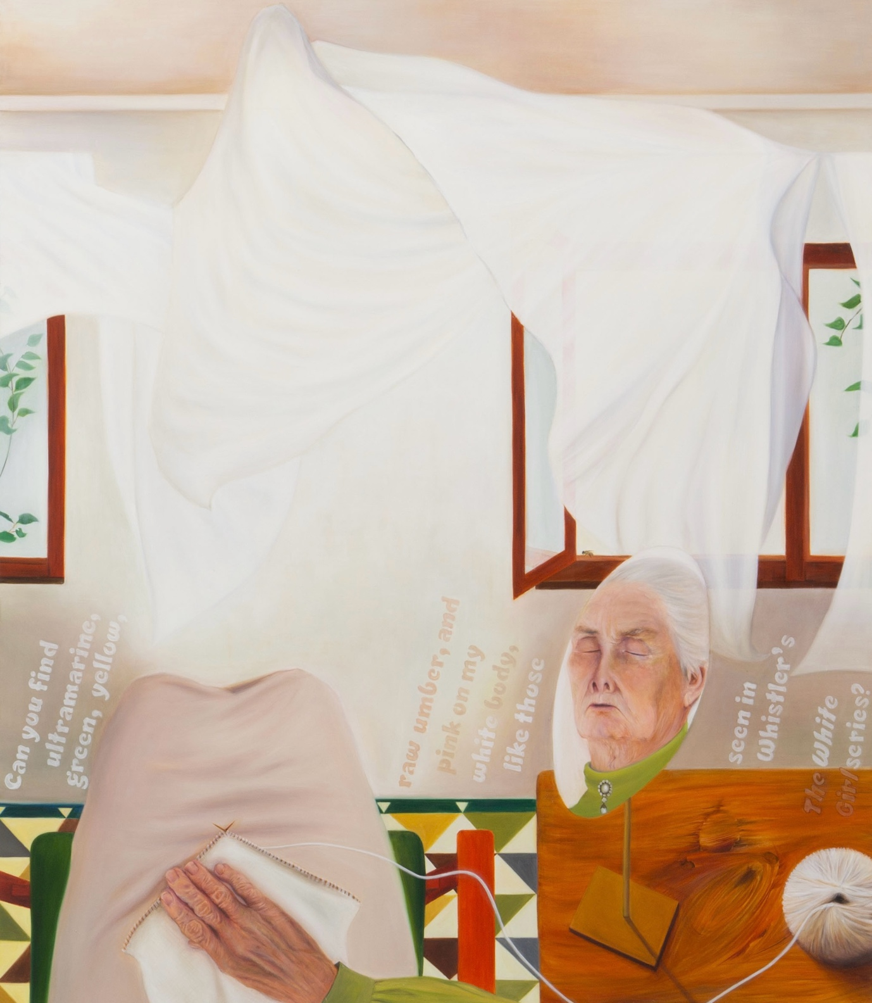
White on White—Pianissimo, 130 x 150 cm, oil on canvas, 2025

White on White—Pianissimo

Can you find ultramarine, green, yellow, raw umber, and pink on my white body, like those seen in Whistler’s The White Girl series? Or in Monet’s Snow Scene at Argenteuil? Degas was another Impressionist who addressed me, capturing the texture of cotton in his Cotton Merchants in New Orleans.

But if I were to name a few of my favourites, they would be Gérôme’s A Pierrot in the Snow and The Descent from the Cross by Rubens. Ah, you shouldn’t miss looking at Carolus-Duran’s Sleeping Man. Each of them handled me with mastery—through their hands, I became a spellbinding presence across the canvas. Sometimes, you may feel otherworldly with me. Even more so if you look at the inscription Goya left on the sand beside his White Duchess.

I have been beloved and beholden by masters and now sing a lullaby for you, who cannot sleep with insomnia. The wind I accompany will carry my song. When it finally reaches you, you will hardly feel its gentle breeze, only realise that your nightmares no longer visit you.
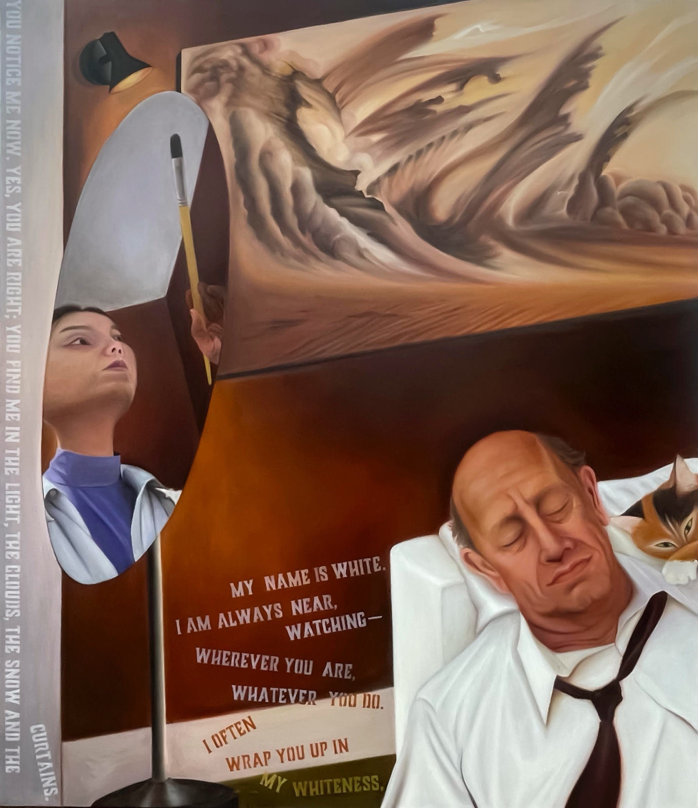
White in Brown—Sandstorm, 130 x 150 cm, oil on canvas, 2025

White in Brown—Sandstorm

You notice me now. Yes, you are right; you find me in the light, the clouds, the snow and the curtains. My name is white. I am always near, watching—wherever you are, whatever you do. I often wrap you up in my whiteness, like the white shirt you wear tonight, feeling every breath of yours as soft as the night air. A hush of warmth behind your unblinking eyes melts into my skin.

Do you hear the sandstorm on the askew wall? The swirls of raw umber twisting the air? The howl of dust as it tears down the land, swallowing the sky? Battling dunes, whirling earth—nothing visible, only the pull of vertigo. You sit unmoved. And I, resting on your skin, hear it all—like the cold embrace of your velvet tie, tightening in silence felt but never truly heard.

